Create Observer
- Interface
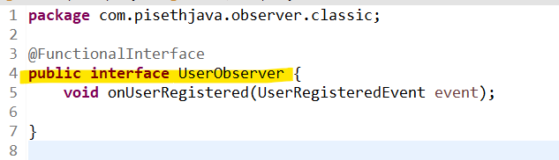

- Implementation

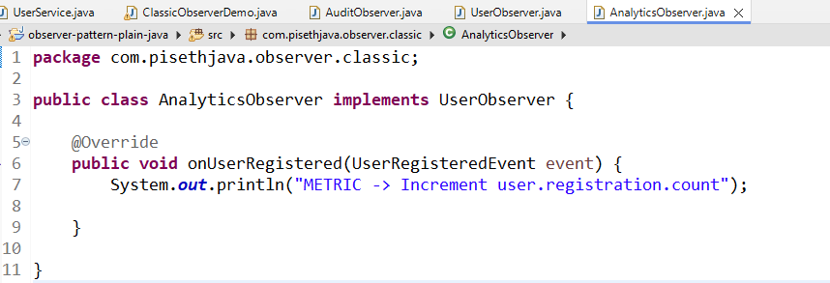

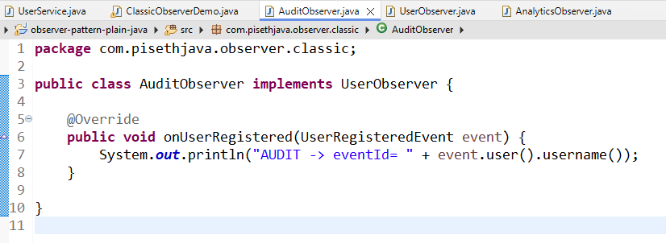

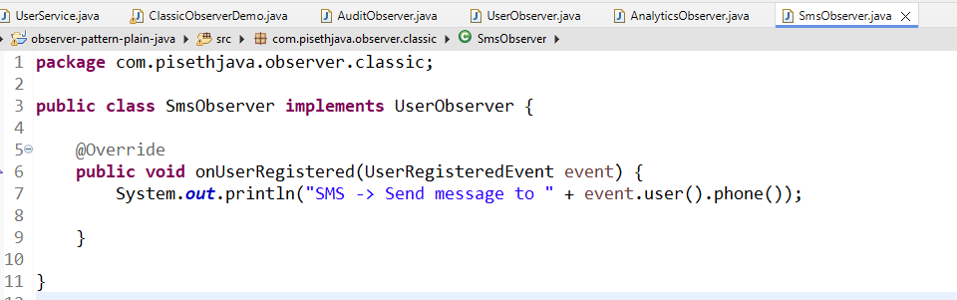

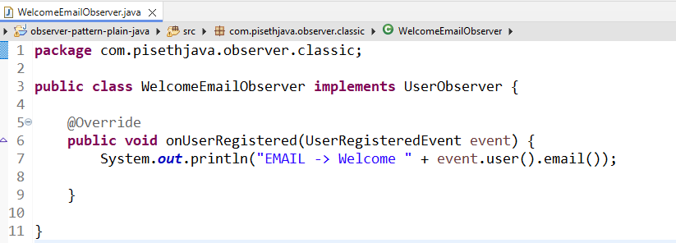

- Crete model
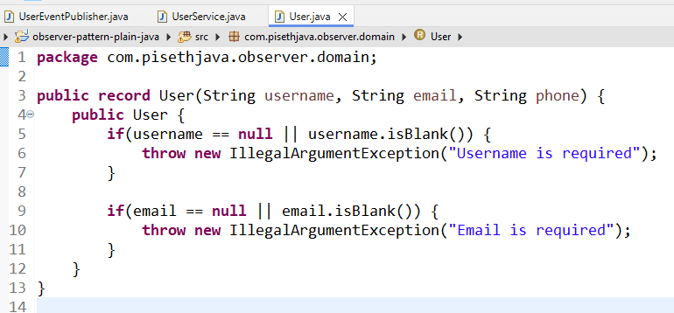

- Service
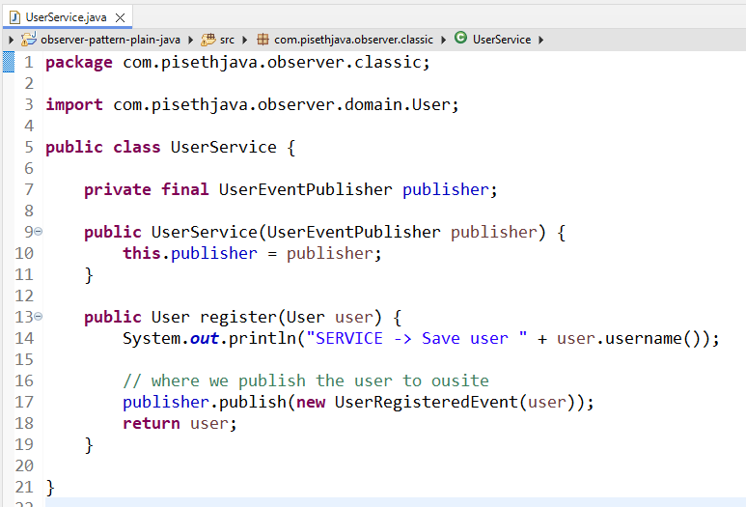

- UserService សម្រាប់ធ្វើការទាំំងឡាយណាដែលទាក់ទងនឹងវា

public User register(User user) {
System.out.println("SERVICE -> Save user " + user.username());

// where we publish the user to ousite
publisher.publish(new UserRegisteredEvent(user));
return user;
}
វាធ្វើការ Register User ដែលយើងធ្វើការ បោះ User ចូលហើយវាធ្វើការតែការចុះឈ្មោះនឹងនោះទេ
ពេលវាធ្វើហើយ វា Publish User នឹងអោយទៅខាងក្រៅទៅចប់ហើយ

// where we publish the user to ousite
publisher.publish(new UserRegisteredEvent(user));

ដែលសម្រាប់ការធ្វើ​ Publisher នឹងគឺយើងប្រើប្រាស់ Server UserEventPublisher

private final UserEventPublisher publisher;

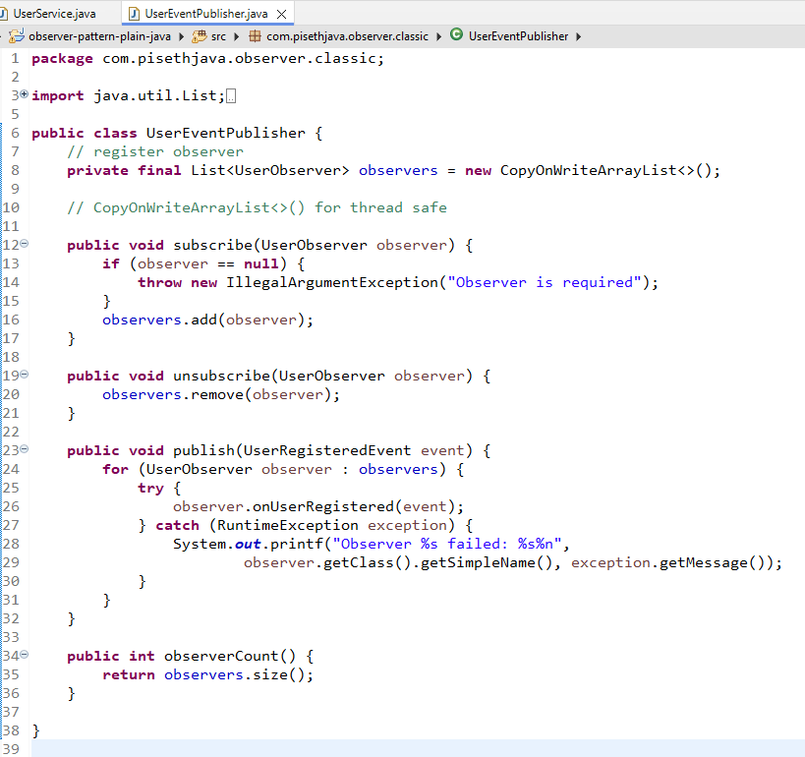

package com.pisethjava.observer.classic;

import java.util.List;
import java.util.concurrent.CopyOnWriteArrayList;

public class UserEventPublisher {
// register observer
private final List<UserObserver> observers = new CopyOnWriteArrayList<>();

// CopyOnWriteArrayList<>() for thread safe

public void subscribe(UserObserver observer) {
if (observer == null) {
throw new IllegalArgumentException("Observer is required");
}
observers.add(observer);
}

public void unsubscribe(UserObserver observer) {
observers.remove(observer);
}

public void publish(UserRegisteredEvent event) {
for (UserObserver observer : observers) {
try {
observer.onUserRegistered(event);
} catch (RuntimeException exception) {
System.out.printf("Observer %s failed: %s%n",
observer.getClass().getSimpleName(), exception.getMessage());
}
}
}

public int observerCount() {
return observers.size();
}

}

